**CS 555: Introduction to Visual Information Processing**

**Assignment 1**

Answer 1:

Given image subsets:

S1 S2

0 0 0 0 0 0 0 1 1 0

1 0 0 1 0 0 1 0 0 1

1 0 0 1 0 1 1 0 0 0

0 0 1 1 1 0 0 0 0 0

0 0 1 1 1 0 0 1 1 1

The two subsets are m-adjacent as explained using the following modified subset matrix representing the connectivity:

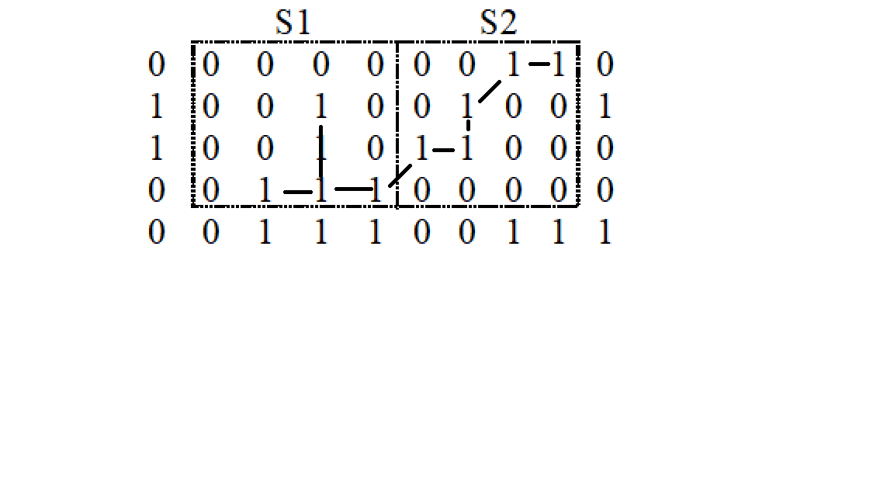

Answer 2:

(a).

Shortest 4-connected path does not exist because the encircled pixel shown in the following diagram does not have a common 4-connected neighbor with pixel Q.

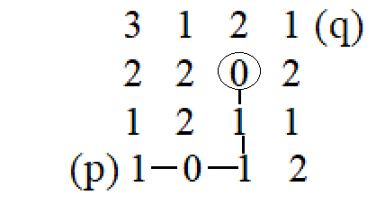

Length of shortest 8-connected path: 4

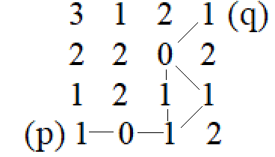

Length of shortest m-connected path: 4

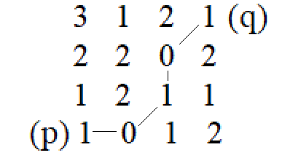

(b).

Length of shortest 4-connected path: 6

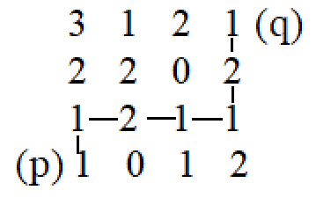

Length of shortest 8-connected path: 4

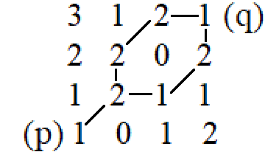

Length of shortest m-connected path: 4

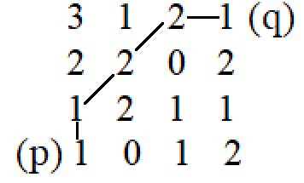

Answer 3:

(a).

EXTADD(f,g) block diagram:

